|  |  |
| --- | --- |
| **Business Process:** | **Business Technology Office - SUNTAX** |
| **Tax Type:** | **All** |
| **Activity:** | **Managing ECO Team Leads** |
| **Sub-Activity:** | **ZICM_WORKLIST** |

**Purpose/Objective**

GTA’s new Education and Compliance Outreach (ECO) program will be managed and reported from Integrated Compliance Management (ICM). ECO leads will be created and managed using ZICM_WORKLIST. This job aid explains several actions ECO Caseworkers will take when managing ECO leads.

**Steps**

ECO Caseworkers will access the lead information using transaction ZICM_WORKLIST. When the worklist displays, double-click on the row of the lead you wish to open.

The “Edit: Compliance Lead xxx” screen displays.

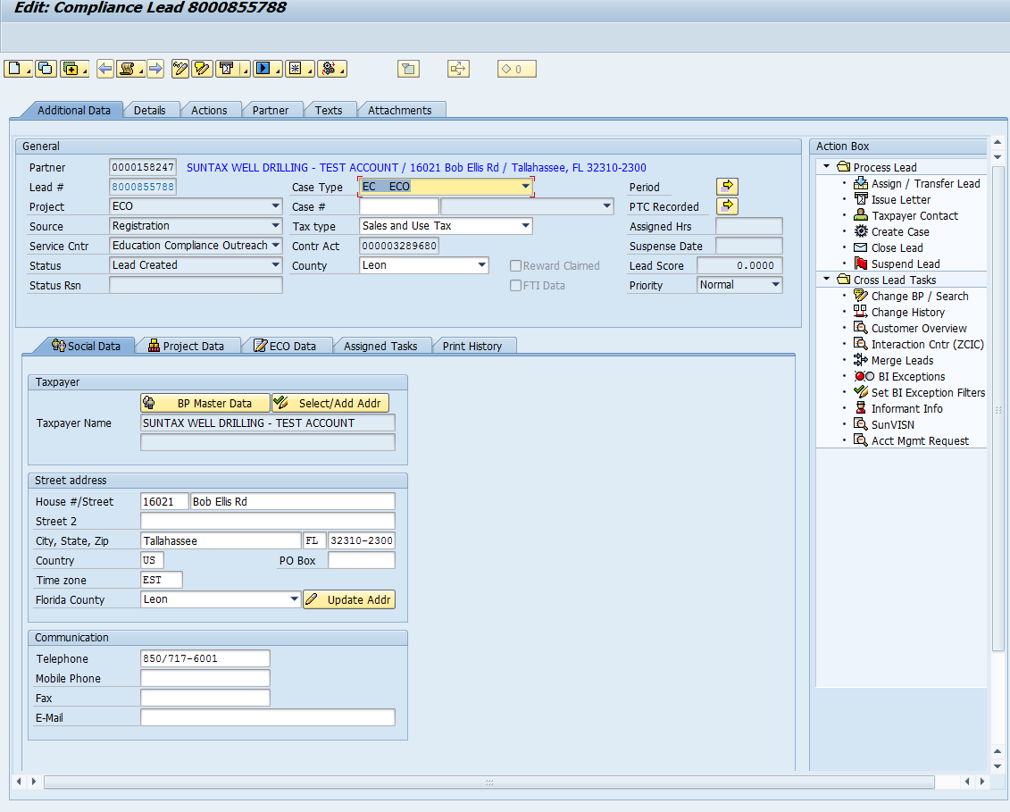

***Note: The lead must be in edit mode to make changes. If the lead opens in display mode, click .***



**Update Address**

Review the address information listed on the Social Data tab.

Enter the address information.

Click the Update Addr button and Yes to continue.

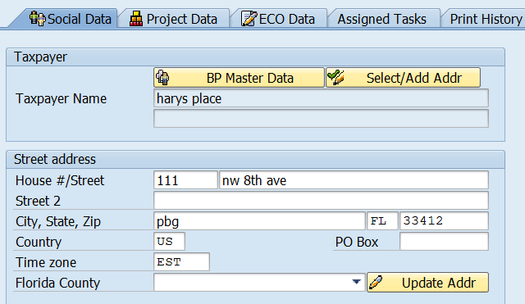

***Note: Changes made on the lead update the business partner information in CRM only. If the change of address should be made to the business partner account, users must also update the business partner account in ECC (PRD) by opening a session in ECC, accessing the Business Partner account, and selecting Taxpayer Social Changes in the Action Box.***

**Action Box**

The most commonly used action box items for ECO leads are:

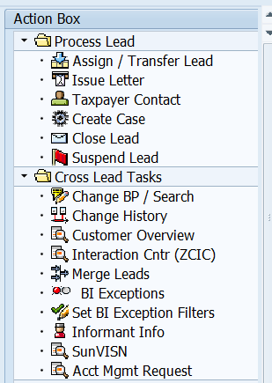

***Note: Never use the Create Case action item for ECO leads.***

**Issue Letters**

To issue a START letter, select Issue Letter from the Action Box.

Click Issue Letter.

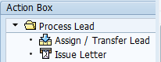

Then select New Registrant letter and click Continue. The letter is sent to the print queue. Click to save your changes. Then click to return your worklist. You can access other leads and repeat these steps to issue the New Registrant letter. When you are ready, click on the worklist to print all letters in the print queue.



The lead Print History tab lists the User Name who issued the letter, the User Name who printed the letter, and the print date.

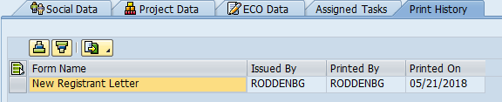

***Note: Print Date populates when the letter is printed, not at Issue Letter.***

**Creating Taxpayer Contacts**

When a taxpayer contact is made, the ECO Caseworker will enter a note in the Record Taxpayer Contact window.

Click Taxpayer Contact.



The Record Taxpayer Contact window displays.

Select the type of taxpayer contact in the Description section.

Enter the details in the Note section.

Click Continue.

Click Save.

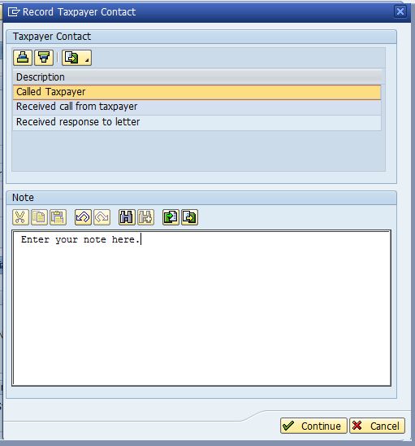

***Note: The Taxpayer Contact note will be saved on both the Text tab and Details tab.***

**Closing a Lead**

After contact with the taxpayer has been made, social information has been verified, and education has been offered, the ECO Caseworker will close the lead. Be sure to add all relevant notes to the Business Partner account in ECC (PRD) as well.

Click Taxpayer Contact.

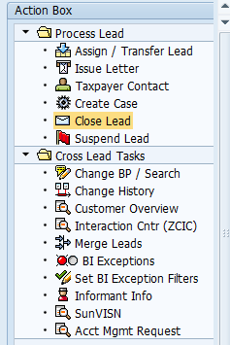

Click . A message will display confirming the lead is closed.



The lead will no longer display on the Caseworker’s worklist. To view closed leads, use the button on the worklist screen to open the Selection Criteria screen. Here you can search by the lead number for a specific lead or search by status for closed leads.

